ST BRENDAN’S CATHOLIC PRIMARY SCHOOL
TECHNOLOGY DESIGN BRIEF
RATIONALE
The aim of the School Technology Design Brief is to identify the ways in which St Brendan’s Catholic Primary school will utilise technology to support curriculum delivery and improve student outcomes by connecting targeted teaching practice with engaged student learning. Technology is best utilised when schools demonstrate explicit links between the curriculum (learning intent), teacher practice (targeted teaching) and technology supported student learning (engaged learning for focussed outcomes).
Essentially, to achieve optimal outcomes, technology assisted learning must be linked to the curriculum and follow teacher instruction. It is a tool to assist learners build their skills, whilst offering a differentiation of learning to others. Technology it is not to be relied upon for each lesson.
PURPOSE
Digital Technologies provide significant opportunities for staff to access the VC, target student learning and authentically engage the students through the provision of appropriate levels of explicit teaching, scaffolding and reasonable adjustments.
Design and Technologies aims to develop the knowledge, understanding and skills to ensure that students:
- become critical users of technologies, and designers and producers of designed solutions
- can investigate, generate and critique designed solutions for sustainable futures
- use design and systems thinking to generate innovative and ethical design ideas, and communicate these to a range of audiences
- create designed solutions suitable for a range of contexts by creatively selecting and safely manipulating a range of materials, systems, components, tools and equipment
- learn how to transfer the knowledge and skills from design and technologies to new situations
- understand the roles and responsibilities of people in design and technologies occupations, and how they contribute to society.

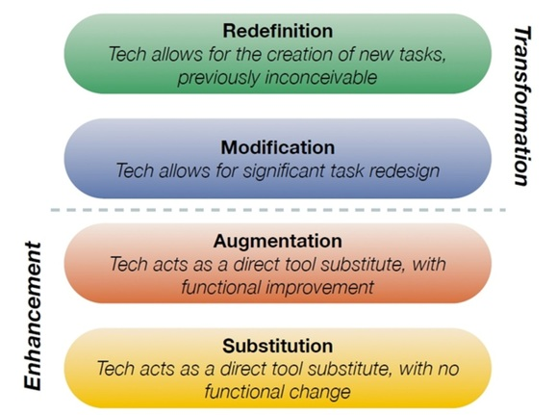
STRATEGY
St Brendan’s CPS will provide safe, modern and easily accessible technology for all students and staff. The St Brendan’s Catholic Primary School Information Communications Technology (ICT) and Technology Student User Agreement
must be signed by all parents and by students in years three to six.
The SAMR model is to be used at the planning table to ensure technology is used as a tool.
Learning progression based on the Victorian Curriculum comes first. Decisions for using technology to support this progression will be made on this basis using the SAMR model to ensure it is meeting the needs of the students and teachers.
St Brendan’s staff will develop their knowledge and use of the SAMR model to guide teacher integration of learning technologies.

Curriculum planning that demonstrates technology is utilised to meet the learning needs of students, to promote problem solving and to enhance communication and collaboration. Improved learning outcomes by students PAT, NAPLAN, Seesaw posts and increased levels of engagement noted in Insight SRC will be measures of success.

Voice text tools can be used to assist students who struggle to type or write.
GAFE to be utilised by all staff and the Year 3-6 students. Explicit instruction by teachers in the use of technology will be evident across the school.
Learning software such as Reading A-Z, Mathletics and Typing.com will be accessed by students on a weekly basis.
STEM will be taught as an integrated learning area, the teacher implementing will be supported with the appropriate professional learning.

IMPLEMENTATION
Expectation of the role and use of technology in the learning process will be reviewed yearly and communicated to the school staff at the beginning of each school year.
To support the building of teacher capacity in this area, explicit focus will be included in the professional learning/collaborative planning cycle. Focus areas will be GAFE and SAMR.
Seesaw will be used by teachers as a reporting tool to parents. Teachers must follow the school’s Seesaw Guidelines for implementation.
All students have access to ipads, Chromebooks and laptops.

