St Brendan’s Primary School

Child-friendly Edition of
our Child Safety Policy

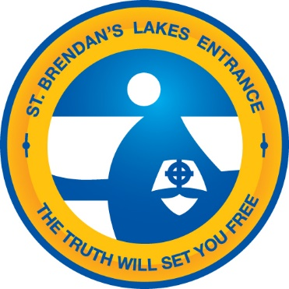

Date of policy: June 2018
Date of last major review: June 2018
Date of next major review: June 2019
Policy Title | St Brendan’s Primary School Child-Friendly Edition of our Child Safety Policy  June 2018
Introduction | What does our school value and why is child safety important in our school?  St Brendan’s Primary School values that everyone can receive a quality education. Students should not have to worry about feeling safe. Students want to look forward to coming every day, school should be enjoyable. St Brendan’s Primary School is a place where everyone cares about each individual’s well-being.
Purpose | Why do we have a policy?  The St Brendan’s Child Friendly Edition of the Child Safety Policy is in place so that all members of our community understand that the safety and protection of children is our number one priority. This policy is in place to be accessible to children as well as adults.
Principles | What are the important ideas that guide our actions?  - Every child and young person has the right to be safe  - Students need friendly staff who are easy to talk to. Staff who can give guidance, will be supportive, respectful and will maintain professional expectations.  - Violence of any kind is not tolerated  - The school environment is safe, supportive and inclusive  - Staff, parents and the community work together to keep children safe at all times  - Every child has the right to a quality education where they are taught how to stay safe now and into the future  - Our principal will ensure that staff members are up to date with child safety policy and procedures  - All cultures and backgrounds are respected and children can feel safe to be themselves
Policy commitments | What pledges do we make to our school community?  St Brendan’s is a ‘safety first’school.
Expectation of our  school staff | Why do we have a Code of Conduct for adults working in our school?  We have the Child Safety Code of Conduct so that adults in our community know how to behave
Student participation | How are students involved in child safety discussions and planning for improvements in our school?  Students and staff will meet regularly to update this policy.  School conducts regular Child Safety awareness days. Example ‘Day For Daniel’, ‘Walk to School Day’, ‘Cyber Safety and Bullying Prevention Workshops’
Reporting and responding | How do we report our concerns and how do teachers respond?  Students feel comfortable in approaching their Class Teacher, Learning Aid or Principal.  All staff act in accordance with their training in line with the Reporting Guidelines.
Recruitment | How are staff selected to work in our school?  Staff at St Brendan’s Primary School:  - will be approachable and easy to interact with  - have child safety at the forefront of their mind  - will be good listeners and will always help  - care about the well-being of each individual  - will be respectful and professional  - will be knowledgeable about and follow the CEVN Child Safety Guidelines
Professional learning for school staff | How does the school support staff to develop their knowledge about child safety?  Child safety is a set agenda for staff meetings. All staff have access to our policies. We regularly undertake professional learning to ensure all staff members understand the policies and procedures in relation to child safety and child protection.
Risk management | How does our school identify possible risks, who is involved and what happens next?  St Brendan’s Primary School will conduct regular safety checks and maintain appropriate VRQA standards.  Regular Evacuation/Lockdown drills will take place.
Supporting documents | What other information do we use to help us?  References:  https://cevn.cecv.catholic.edu.au/WorkArea/DownloadAsset.aspx?id=8589943554  http://www.cecv.catholic.edu.au/getmedia/095514e2-c391-4c76-8d0f-f870f72dd1b3/Child-Safe-Standards-7.aspx  https://www.danielmorcombe.com.au/  http://www.education.vic.gov.au/Documents/about/programs/health/protect/ChildSafeStandard5_FeelingSafePrimarySchool.pdf  https://studentwellbeinghub.edu.au/home/?origin-host=www.safeschoolshub.edu.au  https://youcandoiteducation.com.au/
Communication | How does the school let everyone know about this policy and our plans?  St Brendan’s Primary School will inform our community by placing our child-friendly edition of the child safety policy on our website. We will attach the policy to our newsletter and post a copy on our school noticeboard.
Review | When will we update this policy?  June 2020  Example: The policy will be reviewed every two years and will incorporate suggestions from teachers, volunteers, other staff, children.

